My Camera and Me – Educational Toolkit
The Portapak Camera

The Portapak camera allowed independent videographers to document the social and political changes of the 1970s via video. This educational activity, which includes a characterization of this period of Quebec’s history and its social phenomena, and a demonstration of the links between a video made in 1975 and the sociocultural elements it addresses, can be carried out as part of a Secondary 4 History or Visual Arts class.

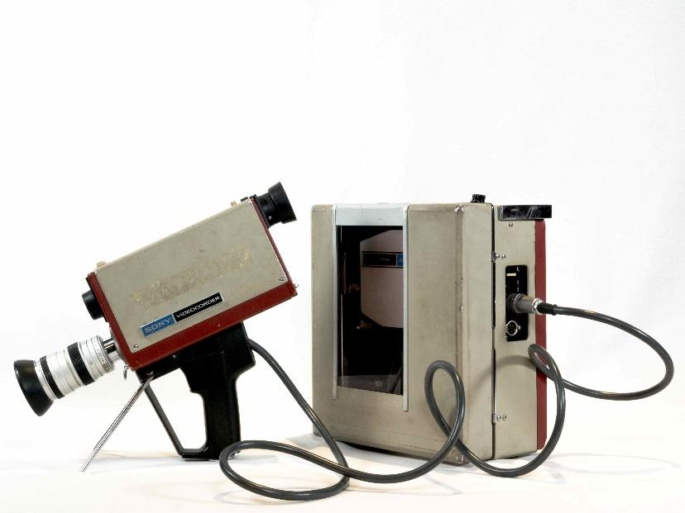
Sony Portapak Video Rover II AV-3400 1/2-in. Camera and Recorder
Cinémathèque québécoise collection 1993.0395.01-03. AP
TECHNÈS CC BY-SA 4.0

This activity is based on the academic curricula of the following subjects:
- History of Quebec and Canada, Cycle Two (Secondary 4)
  - Competency 1: Characterizes a period in the history of Québec and Canada
  - Competency 2: Interprets the social phenomenon “The modernization of Québec and the Quiet Revolution”
- Visual Arts, Cycle Two (Secondary 4)
  - Competency 2: Creates media images
  - Competency 3: Appreciates images

Background of the creation of this camera
This content may be shared by the teacher to introduce the activity.

Starting in the 1960s, Quebec went through a period of modernization and economic prosperity characterized by political changes and a new sense of identity. The preceding period, called the Grande Noirceur, refers to the second mandate of Premier Maurice Duplessis (1944 to 1959), the leader of the Union Nationale political party. The Grande Noirceur ended with Duplessis’s death in 1959 and the election of Jean Lesage in 1960.

The Duplessis era was marked by the premier’s anti-communist stance (he opposed union demands), his adherence to tradition and his relationship with the Catholic Church (which was highly involved in the management of schools and hospitals). In the late 1950s, the people of Quebec began to seek more cultural and economic freedom. The moral authority of the clergy was called into question by artists, unions and the media. The election of Jean Lesage, leader of the Quebec Liberal Party, marked the beginning of the Quiet Revolution. Lesage introduced reforms to the education, health care and social services systems and invested in the modernization of Quebec society. His contributions included nationalizing the electricity service (1962), adopting the Hospital Insurance Act (1962), reforming the Quebec Labour Code (1964), creating the Quebec pension Plan (1965) an adopting the Social Aid Act (1969).

This period also gave rise to increased recognition of women’s rights. Starting in 1964, women gained greater access to higher education and could apply for jobs previously held by men. Spurred by their desire for equality and freedom of choice, women made their voices heard and secured legal gains, such as the ability to sign documents without their husband's consent. They also obtained social recognition; one example of this was the holding of the 1967 Royal Commission of Inquiry on the Status of Women, which had been demanded by the Fédération des femmes du Québec.

Although certain gains were made during those years, the social pressures women faced nevertheless slowed their emancipation.

The 1970s were also rather turbulent. Of note were the nationalist movements (recognition of provincial jurisdictions, self-government in Quebec, the protection of the French language); the demands for recognition of the rights of Indigenous persons oppressed by the Indian Act; and the endeavours of trade unions (who sought to put an end to the inequalities engendered by capitalism).

In the 1960s and 1970s, Quebec society was in flux. Important changes were taking place, and groups of artists and independent filmmakers used the Portapak camera to bear witness to them. Video, which could be broadcast on community networks, became a tool for democratizing mass media. Its portability allowed its users to go out into the world, produce news reports and communicate their messages to society. It also gave rise to community television, favouring freedom of expression, civic engagement and involvement in social changes.

Learning Activity

After reading about the Portapak in the Discover the Cameras section, and by applying the knowledge they have acquired in the Secondary 4 History of Quebec and Canada course, students are invited to contextualize the creation and use of the Portapak camera by answering the following questions, and to view a clip from the film Philosophie de Boudoir.
- Background
- In what year did the Sony Video Rover II Portapak become commercially available?_______
- What considerations led to its creation? ________________________________________________________________
- When video emerged, what was taking place in Quebec? ________________________________________________________________
- Following the election of Jean Lesage in 1960, a period of change took place in Quebec. What is this period called?
________________________________________________________________
- Were Quebec’s social movements over by 1970? If not, what issues remained?
________________________________________________________________________________________________________________________________________________________________________________________________
- Why did people choose to use the Portapak in this context?
________________________________________________________________________________________________________________________________
- This camera does not use film. What breakthroughs were made possible by the portable recorder and magnetic tape, that were not possible with film?
________________________________________________________________________________________________________________________________

- Philosophie de boudoir movie clip
- In what year was Philosophie de boudoir shot? ______________________
- What social phenomenon did directors Helen Doyle and Nicole Giguère wish to expose? ________________________________________________________________________________________________________________________________
- In what social context did they undertake this project? ________________________________________________________________
- Do the directors appear in the clip or did they film the scene from an outsider’s point of view? __________________________________________
- What method they did employ to collect their footage? _______________________

- Produce a “vox pop.”
Today, nearly 50 years after the release of Philosophie de boudoir, what issues do you think women face in society?
This project can be completed in four steps.

1. Preparation of the interview:
  - Draft a series of questions that address the issues.
  - Identify the people you would like to interview and obtain their permission to do so.
  - Write down the location where you would like to hold the interview.
  - Consider the impact your questions will have on your interviewees. Consider also the impact their responses could have on your viewers. What is your overall intention?
2. Recording:
  - At your designated location, record a video using a video camera or your mobile phone, and incorporate transforming gestures to enhance your message (placement of the camera vs. placement of the subject, in-camera effects such as close-ups and/or camera movements).
3. Editing:
  - Edit your video (add visual or sound effects, if desired, in accordance with the purpose of your video).

- Projection:
  - Share your vox pop with the class.
  - Discuss the responses of your interviewees with the other students. Do all your interviewees share the same opinion? Did any of their responses surprise you? Discuss your creative experience (the challenges you faced, the creative choices you made to optimize your project).

Answer key for the teacher

A. Background
- In 1970.
- Ideas about the role of communications and a need for compatibility with the burgeoning medium of television.
- It became available in the era of woman’s liberation and the social movements of the 1960s and 1970s.
- The Quiet Revolution.
- No. Examples include nationalism, women's liberation, Indigenous rights and trade unions.
- With this camera, filmmakers were able to participate in the social debates of the day by leaving the studios behind, recording subjects’ stories and sharing them on community networks.
- The portable recorder records signals from the camera; the video can be rewound and viewed immediately after the shoot. Magnetic tape can be erased and reused several times. The system produces a low-definition image that can easily be broadcast on television.

- Philosophie de boudoir movie clip
- 1975.
- The perception of feminism at the Women’s Show.
- In a context where women in Quebec were asserting their rights and claiming their place in society.
- They appear in the clip. They interviewed attendees on location at the Women’s Show.
- Through a vox pop. This term comes from the Latin expression “Vox populi,” which means “voice of the people.”

