My Camera and Me – Educational Toolkit
The Bell & Howell Camera

Travel back in time to the early 20th century and the heydays of the film industry to learn about the invention of the Bell & Howell camera. Through the analysis of a written document and a reading comprehension exercise, students will discover this camera’s background. Drawing on technological concepts, this educational activity can be conducted in Secondary 3 Science and Technology or English Language Arts courses.

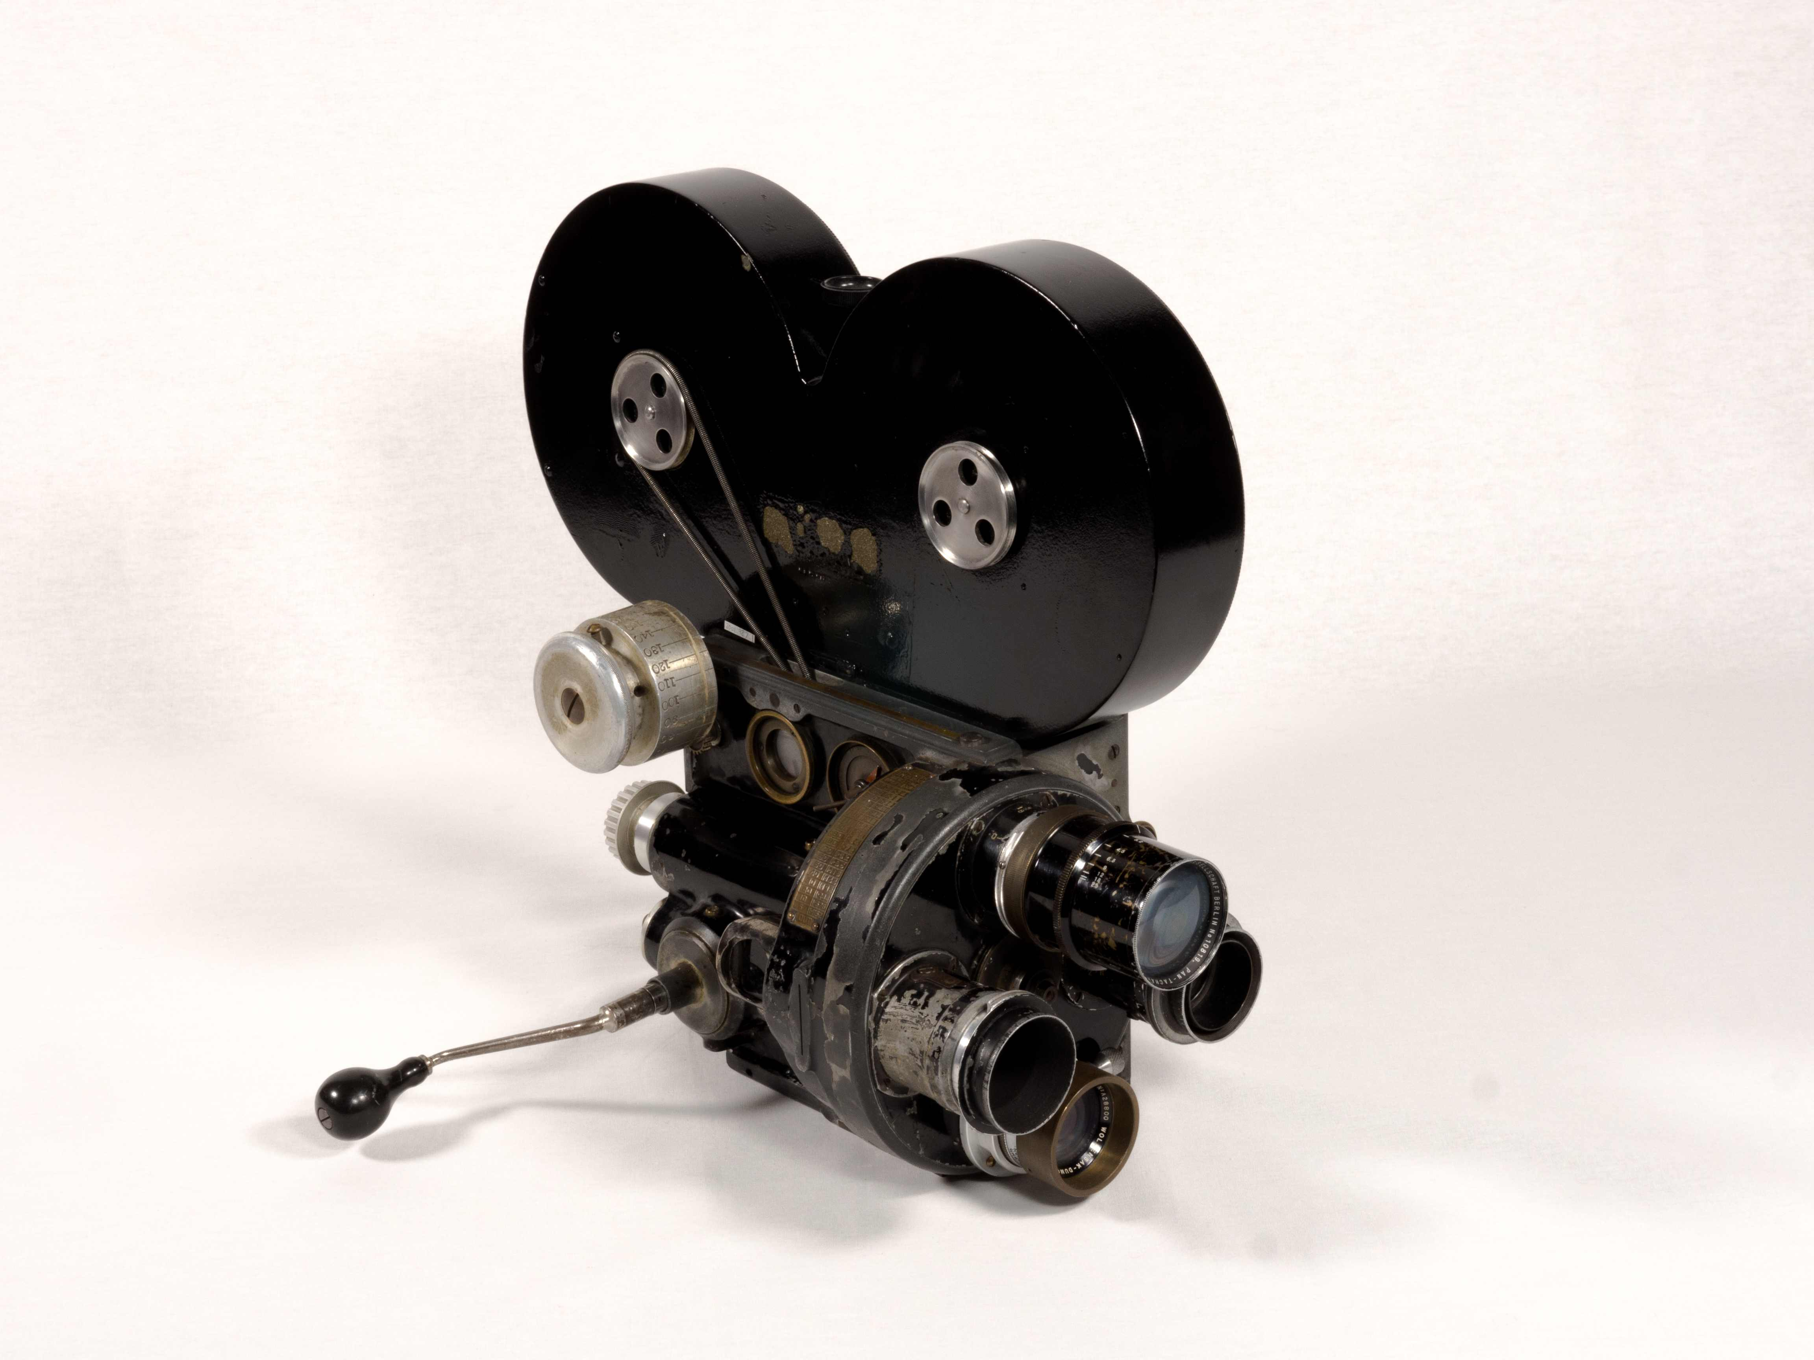
Bell and Howell 2709 35 mm Camera
George Eastman Museum collection
TECHNÈS CC BY-SA 4.0

This activity is based on the academic curricula of the following subjects:
- Science and Technology, Cycle Two (Secondary 3)
  - Competency 1: Seeks answers or solutions to scientific or technological problems
- English Language Arts, Cycle Two (Secondary 3)
  - Competency 2: Reads and listens to written, spoken and media texts

Background of the creation of this camera
This content may be shared by the teacher to introduce the activity.

In the early 1900s, the film industry was well-established in Chicago. As early as 1905, a large number of movie theatres, called nickelodeons, had opened in the city. For five cents, it was possible to watch short, silent films, which were usually accompanied by live tunes played by a pianist. The term “nickelodeon” combines the word “nickel” (five cents) with the Greek word “odeon,” which refers to the enclosed buildings where concerts were held in Ancient Greece (5th century BCE).
Public enthusiasm for “animated views” prompted movie studios to acquire better equipment. To create a camera with higher image quality, and by the same token serve the growing film industry, Donald J. Bell and Albert S. Howell joined forces to form the Bell & Howell Company in Chicago. In 1911, Howell filed a patent for his “Motion Picture Machine,” which was the original wooden model of what would become his next camera, the 2709 Model B. In 1912, the new model, this time made of metal, was launched. It went on to be widely used by studio operators.
From the late 1910s to the late 1920s, the Bell & Howell was the most widely used camera in Hollywood. Considered the leading edge in professional cameras, it was also used in Canadian studios. It was large and heavy and had to be mounted on a tripod. It was recognized for the high quality and sharpness of its images, as well as for its ingenious focusing system. The features of the Bell & Howell that made it the studio camera of choice, and that influenced the practices and aesthetics of cinema as we know them today, began with a simple idea.

Learning Activity
The invention of technological devices, including cameras, is directly linked to the development of science and industry. Meanwhile, the written documents that accompany or describe them are considered evidence of society’s evolution. A document containing a large amount of technical information was written in 1911 and updated in 1912. This information was highly relevant to the creation of the Bell & Howell 2709 Model B camera. In this activity, students will be invited to analyze this patent and its accompanying information, which can be found on the Bell & Howell page of the Discover the Cameras section, and then answer the following questions:
- What was the author’s name? ________________________________________
- What is the nature of this document? __________________________________
- Figures 1 and 2 show the camera in profile. What is the technical term for this type of drawing (students can find the answer on page 4, line 19)? ________________________________________________________________
- According to your knowledge, what was the purpose of drawing the cross-sections of the camera, as seen in figures 1 and 2? ________________________________________________________________
________________________________________________________________
- Referring to the description of the document, explain why the author presents the camera’s drive mechanism in this way.
________________________________________________________________________________________________________________________________
- The author added numbers to the drawings. What purpose do they serve?
________________________________________________________________
- Are these technical drawings to scale? __________
To better understand the context of this document, students are invited to read the Bell & Howell information sheet and then answer the following questions:
- What job did the author have? ________________________________________
- What was his partner’s name? ________________________________________
- In what city was their company founded, and why? ________________________
________________________________________________________________
Concerning the Bell & Howell 2709 Model B:
- Name two features of this camera: _____________________________
________________________________________________________________
- Name and describe two of its accessories: _____________________________
________________________________________________________________

For a demonstration of the quality of this invention, students may view clips from Carry on, Sergeant! and Back to God's Country. The teacher can then invite them to share their feedback on these clips and discuss the differences between the two films (e.g., were they shot in a studio or outside? Are the films in colour or black and white? Does the camera move or are the shots static (locked off)? Are there any overlapping images?)

Answer key for the teacher

- Albert S. Howell.
- A patent of invention to protect the intellectual property of the inventors and guarantee the inventors’ exclusive rights to the invention.
- An elevation drawing.
- The cross-sections provide a view of the camera’s particular characteristics.
- The author provides a description of the motor, which was developed to allow greater image sharpness when filming.
- The numbers refer to additional information. The author explains certain ideas.
- No, these technical drawings do not feature a scale.
- An engineer in a projector parts factory.
- Donald J. Bell.
- In Chicago, because it was the epicentre of the film industry.
- Refer to the “Specifications” section of the camera info sheet.
- Refer to the “Components and Accessories” section of the camera info sheet.

Nowadays, the term “odeon” still appears in the names of movie theatres in Quebec and elsewhere.

