My Camera and Me – Educational Toolkit
The Aaton Camera

The Aaton camera, nicknamed “cat on the shoulder,” was created to meet a specific technical need of documentary filmmakers: portability! Drawing on competencies from the Visual Arts curriculum, this activity will encourage students to discover creative works through listening, appreciation and analysis. Students will be invited to pay particular attention to the reasons this camera was invented, as well as its contributions to documentary filmmaking.
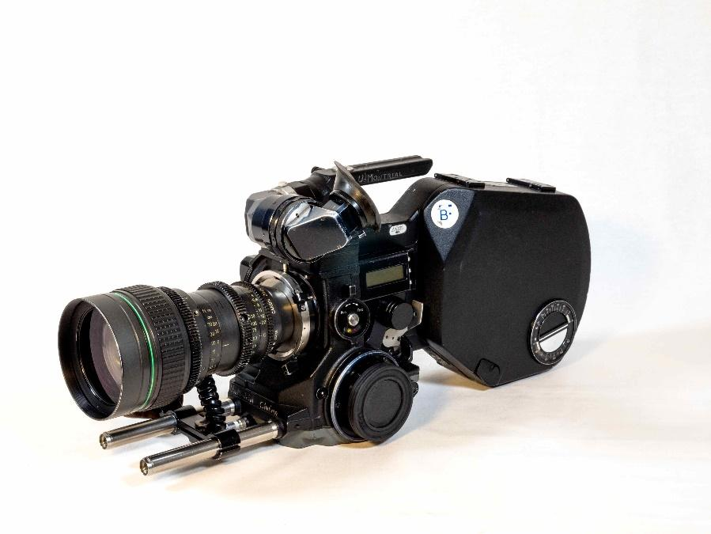
16 mm Aaton XTR Plus Camera
Université de Montréal collection
TECHNÈS CC BY-SA 4.0

This activity is based on the academic curriculum of the following subject:
- Visual Arts, Cycle Two (Secondary 3)
  - Competency 3: Appreciates images

Background of the creation of this camera
This content may be shared by the teacher to introduce the activity.

In the 1960s, documentary filmmakers had a specific desire in common: to record the candid words and actions of people in their own environments. To do so, they needed comfortable, lightweight equipment that remained stable while filming, allowed the camera operator to remain mobile and could record synchronized sound. To meet these needs, Jean-Pierre Beauviala invented the Aaton camera in 1972. Several technical aspects allowed the Aaton to stand out, notably its ability to synchronize sound and image without cables, the quick loading and unloading of its magazines (containing the film), and its precise framing. These features made it the camera of choice, not only for documentary cinema, but also for television reporting and fiction films.
In the 1980s, some of the pioneers of Direct Cinema used the Aaton camera because it met the objectives of this form of documentary film. In Quebec in the late 1950s and throughout the 1960s, young filmmakers employed by the National Film Board (NFB) developed a new approach to filming their subjects’ realities. Their goal was to capture them in their own environments, with no artificial lighting. Although their subjects were filmed “live,” a lot of work had to be done beforehand to prepare the shoot and, even more importantly, to develop a relationship of trust with the people being filmed.
It was generally not difficult for film crews to be accepted by these groups, given that they were normally made up of only two or three people, namely the sound mixer, the camera assistant (who was responsible for the camera’s technical aspects) and the camera operator. Because the camera’s placement on the operator’s shoulder made it so comfortable and stable, the camera operator was able to get much closer to the subjects being filmed…and even to circulate among them!

Learning Activity
Because it allows camera operators to circulate freely among their subjects, the Aaton camera is frequently used to make documentary films. Two examples of films made with the Aaton are Liberty Street Blues and Le roi du drum.
- To learn certain key concepts related to the Aaton camera, students are invited to view clips from Quebec's cinematographic heritage, alone or in groups. These clips can be found on the Aaton page of the Discover the Cameras section of the website. The students are then invited to answer the following questions:
- Who is the subject of the film?
  - Liberty Street Blues (first clip): _______________________________
  - Le Roi du drum: __________________________________________
- Was the clip filmed indoors or out of doors?
  - Liberty Street Blues (first clip): _______________________________
  - Le Roi du drum: __________________________________________
- What is the physical position of the camera operator in relation to the subject(s)?
  - Liberty Street Blues (first clip): _______________________________
  - Le Roi du drum: __________________________________________
- Do the subjects seem aware of the camera operator’s presence?
  - Liberty Street Blues (first clip): _______________________________
  - Le Roi du drum: __________________________________________
- In these clips, are the shots static (i.e., the camera stays in one place)?
  - Liberty Street Blues (first clip): _______________________________
  - Le Roi du drum: __________________________________________
- In these clips, is the zoom feature used? If yes, specify the type of zoom movement.
  - Liberty Street Blues (first clip): _______________________________
  - Le Roi du drum: __________________________________________
- How did you feel as you watched these clips?
  - Liberty Street Blues (first clip): _______________________________
  - Le Roi du drum: __________________________________________
8. Share your point of view with your classmates.

- For additional background information on these films, students are invited to refer to the Aaton Camera page to pursue their research, and then answer the following questions:
- Who directed these films?
  - Liberty Street Blues: _______________________________________
  - Le Roi du drum: __________________________________________
- What is the weight of the camera on the operator’s shoulder? _______________
- Which component is loaded into the camera, allowing it to record both indoor and outdoor scenes? _____________________________________________________
- In these clips, which of the camera’s features creates the effect of moving closer to or further away from the subjects? _____________________________________

- Had these clips not been filmed with a portable camera, what would the final result have been? To conclude the activity, students are invited to share their understanding of how a camera such as the Aaton can be used to capture live footage of a given subject.

Answer key for the teacher
- Film clips
  - The crowd waiting for the parade to start.
  - Drummer Guy Nadon and pianist Vic Vogel.
2.1. Indoors and out of doors.
2.2. Indoors.
3.1. Among the crowd.
3.2. Between the drummer and the pianist.
4.1. Some people notice his presence, but no one pays him much attention.
4.2. Yes, because they are performing for him.
5.1/5.2. No. The camera is not mounted on a tripod.
6.1. Zoom out
6.2. Zoom in
7.1/7.2. Open answer

- Camera information sheet
  - André Gladu
  - Serge Giguère
2. 6 kg, including the batteries and magazines
3. Film
4. The zoom lens

- Classroom discussion
Possible answers include: more distance from the subjects, impossible to take as many shots in a single sequence, certain actions could not have been filmed.

